Aquatrol v.1.0 – user manuals

# controller overview

aquaTROL is a dedicated controller for controlling aquarium equipment. Using bluetooth connection it is possible to view status and adjust parameters. Using internal microSD card it is possible also to log data on SD card, adjust settings as well as update firmware.

## Main functions

* LED lights controlling (3 independent channels)
  + Adjustable LED power (255 steps)
  + Sunset and sunrise with adjustable parameters
  + Programmed on/off time, based on internal clock
  + Possible to turn on/off lights using button (night cleaning etc.)
  + Internal clock with backup battery
  + Galvanically seperated outputs, which support 12/24 VDC power supply (external)
  + Max. 4 A / each channel (100 W per channel, 300 W total)
* Heater controlling
  + 230 VAC output to control heater using DS18B20 temperature probe
  + In case of using heater with internal thermostat, we suggest using Aquatrol as main heater controller and adjusting heater's thermostat to 2-3 degrees higher temperature to use it as backup turn-off mechanism.
  + Max. 10 A/230 VAC
* Skimmer controlling
  + 230 VAC output to control turn on skimmer twice per day (adjustable intervals)
  + Max. 10A/230VAC
* CO2 valve controlling using pH probe
  + 230 VAC output for CO2 valve
  + Max. 10A/230VAC
* Filter pumps controlling (2)
  + 2 independent NC channels
  + Max. 6A/230 VAC
  + »FEED« function: when feeding, pump(s) is disabled for a certain period of time (0-999 s)
  + »UPS BACKUP« function: when running on UPS, pumps are switched on alternately in 15 min intervals, so both filters are active and bacterias survive, but power consumption is low.
* 1 auxilary output (10A/230VAC), function will be defined
* Data logging to SD card
  + Data logging on each action; i.e. lights on, CO2 valva off … (/LOG/DATA.TXT)
  + Periodically logging of all parameters to CSV file (/LOG/LOG.TXT), which can be later processed in Excel
* Parameters setup using file on SD card
  + /CONFIG/CONFIG.TXT
* Firmware update using SD card
  + Copy »AquaTrol.hex« file to root folder on SD card
  + Insert card to controller, power on the system and wait 20 s
  + Turn off the controller
  + Remove card and delete file after upgrade

# CONNECTING THE CONTROLLER

**Warning! There is a mains voltage on the controller! Be careful and first disconnect the power supply cable before doing anything on the controller itself!**

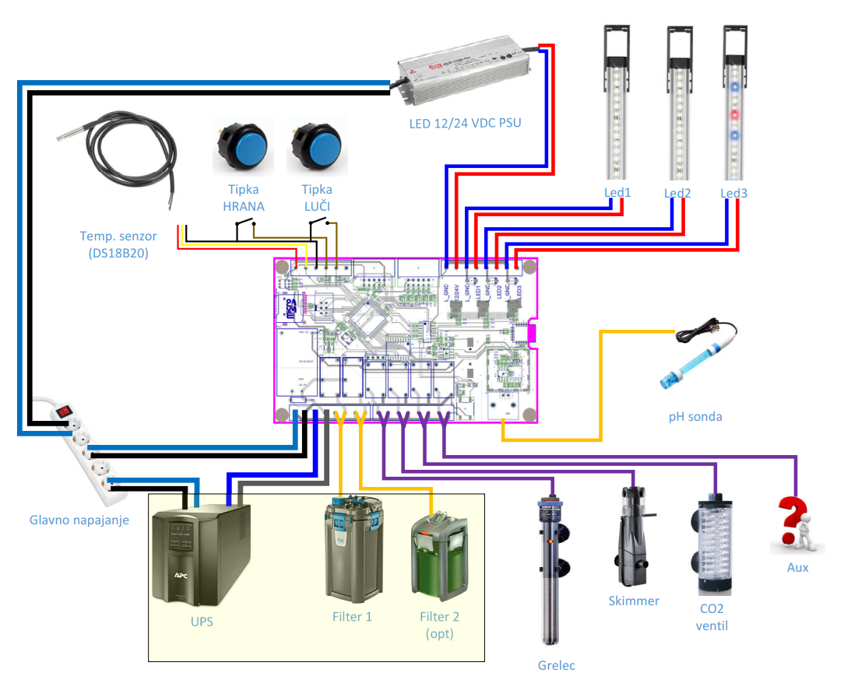

1. Prepare mains cable 230 VAC. **Do not connect cable to the power outlet yet!**
2. Prepare mains cable for UPS (if used). UPS is used to power controller logic and both filters. All other devices are powered through mains power and in case that mains is disconnected are shut off.
   1. If UPS is not used, short pins 1+3 and 2+4!

**Do not connect cable to the UPS yet!**

1. Prepare connectors to all equipment used.
   1. If only one filter is used, connect it to left output (1).
2. Connect LED power supply. Mind the correct polarity! **Do not connect cable to the power outlet yet!**
3. Connect LED diodes to outputs 1-3. Mind the correct polarity!
4. Connect temperature sensor (if used).
5. Connect buttons (if used).
6. Connect pH probe (if used).
7. Insert microSD card (FAT32).
8. Activate UPS power supply. Controller should turn on (see LED diode on it above SD card).
9. Activate mains power supply (230 VAC).
10. Activate LED power supply.

# PARAMETERS SETUP

Parameters are stored in internal EEPROM memory as well as on SD card. If SD card is inserted, data from SD will always be used and copied to EEPROM as well. If no SD card is present, data from EEPROM will be used.

Disconnect UPS 230 VAC power supply. Remove microSD card and insert it into computer. There is a file CONFIG.TXT in the CONFIG folder with following content:

|  |  |
| --- | --- |
| AquaTROL BASIC SETTINGS  /Edit only values, keep formatting!!!/  _________LED 1:__________  255 - power on (000-255)  000 - power off (000-255)  11:00:00 - on time  19:00:00 - off time  1000 - Dimming Step 1(0100-9999)  _________LED 2:__________  254 - power on (000-255)  001 - power off (000-255)  11:15:00 - on time  18:50:00 - off time  1000 - Dimming Step 2(0100-9999)  _________LED 3:__________  255 - power on (000-255)  002 - power off (000-255)  09:00:00 - on time  20:00:00 - off time  1000 - Dimming Step 3(0100-9999)  _______TEMPERATURE_______  251 - target temperature (x.xx)  _________SKIMMER_________  10:00:05 - on time 1  10:15:05 - off time 1  16:00:06 - on time 2  16:15:06 - off time 2  _________CO2 VALVE_______  6.51 - target pH (x.xx)  ________FEED TIME________  300 - feed time in s (xxx)  1 - pumps affected (0,1,2) | **LED channel 1 settings (left)**  Day power (000-255, 255=100%)  Night power (000-255, 0=off)  Sunrise time (time, when sunrise starts)  Sunset time (time, when sunset starts)  Sunset and sunrise speed (1000 approx 15 min)  **LED channel 2 settings (middle)**  **LED channel 3 settings (right)**  **Heater target temperature**  (hysteresis set to 0,2 degrees Celsius)  Skimmer on time 1  Skimmer off time 1  Skimmer on time 2  Skimmer off time 2  **CO2 valve pH setting**  (hysteresis set to 0,1 pH)  **Filter disable when feeding**  Feeding time – filter disabling in seconds  0-disabled, 1-filter 1 only, 2-both filters |

**You may change all values, but keep in mind, that you must not change formatting (i.e. write 100 instead of 0100 or insert/delete some line(s).**

# TIME AND DATE CHANGING (rtc)

Create file TIME.TXT using notepad. Its content should be exactly in following format:

|  |  |
| --- | --- |
| 12:32:00  04/06/20 | Time  Date |

When system will startup, file will be read and RTC time will be updated. File will be deleted automatically.